Assigemnt 8

1) Assume each salesperson has a 12% commission.
Write a query on the orders table that will produce
the order number, the salesperson number, and the
amount of the salesperson’s commission for that
order.
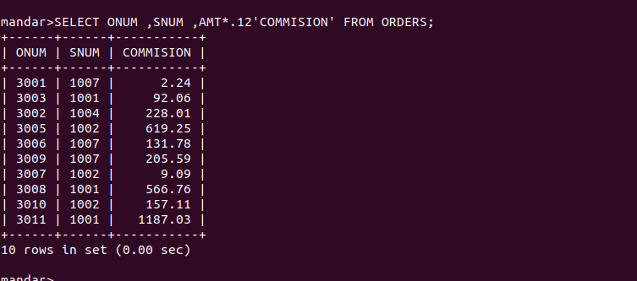

2) Write a query on the Customers table that will
find the highest rating in each city. Put the
output in this form:
For the city (city), the highest rating is :
(rating).

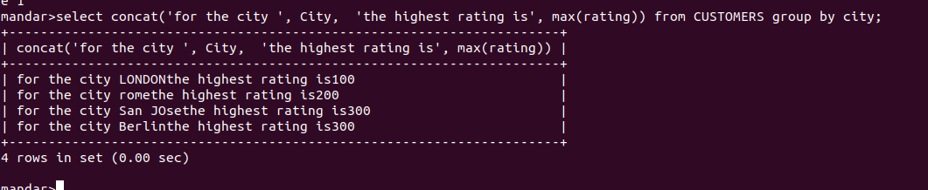

3) Write a query that lists customers in
descending order of rating. Output the rating
field first, followed by the customer’s name and
number.

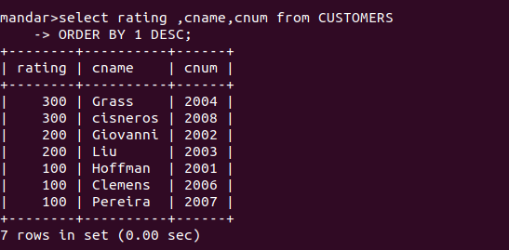
4) Write a query that totals the orders for each
day and places the results in descending order.

